How to practice
The Way of the True Heart
A Taoist Qigong Method
From the Teachings of
Master Hu Xuezhi
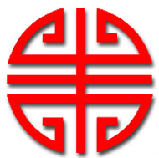

The Tao that can be spoken of is not the eternal Tao;
The name that can be named is not the eternal name.
The nameless is the origin of Heaven and Earth;
The named is the root of all things.
Therefore, the subtleties of the Tao can be experienced by being free from passions and desires.
The things existing in the world of duality can be well known by possessing passions and desires.
The two above-mentioned have the same source but are given different names.
The ability of transformation between the two is a most mysterious thing, or the door of all mysteries.

Tao, which is also called Infinite Nirvana by Shakyamuni and Infinite Emptiness by Confucius, is so vast that it has no limits to confine it. At the same time, Tao is so minute that there is no interior to fill it.

It extends itself far away beyond the limits of the universe and existed long before the beginning of time.

Tao is capable of exhausting infinitude and dates back to the time when there was no beginning whatever and there was no time. Tao was something naturally formed as infinite achromatic chaos, long before the creation of Heaven and Earth. Infinitely still and infinitely comprehensive, it has remained unchanged and independent ever since, functioning within all things in a thoroughly perfect manner without any lapse or error.

Tao gives birth to all universal things and also is contained within all universal things.
The Tao that is contained within is called the Golden Mean or Te in Chinese, and actually serves a function much like the source of spring water or the root of a tree.

Without this root source, the spring water will run dry and the tree will become withered. Such a Golden Mean is also called Primeval Nature or the True Heart. A state that exists when the desires and passions such as happiness, anger, sorrow, joy, and fear, have not yet come into being; a state of complete, perfect stillness.

There has long been a tale telling of a Buddhist who, once upon a time, summed up his experiences through long-time silent exercise, saying, "My form is like a tree trunk, my heart is as clean as a bright mirror. I have been dusting my heart every now and then, lest it should incur even one slight stain."

Upon this, Liu Chu, a great saint, at once pointed to the depth of the truth, saying, "Originally, there existed no tree, nor a clean, bright mirror.
When there is nothing at all, how can dust alight?"

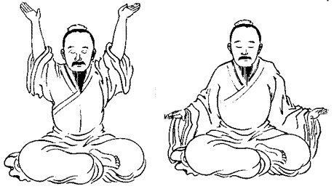

When I practice these postures, one should settle the mind-will in the lower elixir field – located in the empty space 3.8 cm below the middle place between the kidney and navel – a sphere of around 3.8 cm - the lower Tantien.
Let the internal vision gaze upon that place.
Yes, you will behold darkness.
Then slowly think that this darkness begins to expand in all directions. Then your own body slowly disappears in the darkness, your house disappears in the darkness, the town you are living in disappears in the darkness.
Your country disappears in the expanded darkness.

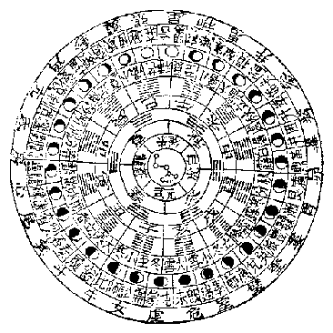
The darkness has expanded so large that the earth disappears in the darkness; the universe disappears in the darkness. Then all things disappear.
I could see nothing, I could hear nothing,
I could think of nothing.
I again return to the time before my birth.

Where I am I could not know.

Where is my body I could not know.

Where is my house I could not know.

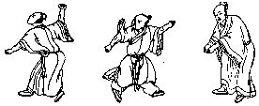

Why could I not know?

Because when I again return to the time before my birth I could not have the capacity to see, to think, to imagine, or
to do anything.

One practitioner said he often hears the sounds made by the birds outside the window. I told him “Do you think you can hear the birds' singing when you are in the time before your birth or after your death?" He replied, "No." then I said, "Now you know how to let your heart be still."

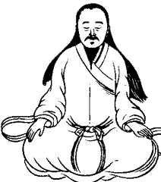

Yes, sometime stray thoughts may intrude upon my heart.

Then I will slightly think of the meaning of –
"emptiness, all disappear, nonexistence."

Then I again return to the time before my birth.

I am a dead man still alive.

Preparatory Work before General Silent Sitting Practice
Eight Steps of Silk Brocade Practice
(Sitting Posture Version)
This school of practice has a very long history in China and once played an important role for Chinese health and mental well being. It is generally used for doing preparatory work for Taoist Silent Sitting Practice.
Yet, if practitioner can have the proper mind will maneuvering approach, it can help practitioner gain much more than they could expect.
This practice can combine with any schools of qigong except the imagining methods should change.
When I practice these postures, one should settle the mind-will in the lower elixir field – located in the empty space 3.8 cm below the middle place between the kidney and navel – a sphere of around 3.8 cm.
To constantly settle mind-will in the lower elixir field is the most important measure for the novices, also the most useful for the common people who for this or that reason only aim at promoting their physical well-being, preserving the good stamina and keeping heart peaceful and broad.

STEP 0 - Preparation  Sit cross legged, slightly close two eyes, hands one on top of the other with thumbs touching, slowly purge of all stray ideas within the heart, position spine upright, and settle mind-will in lower Dantien area. Relax all parts of the body, let tongue rise up to touch the hard palate, with teeth lightly touching. |  |  | 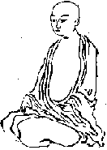
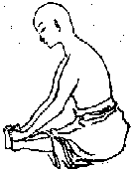 |  | STEP 1  Catch hold of the feet with two hands (see figure at left). Then bow the upper body forward and backward slowly, stretching back and forth out over the feet - 16 or more times.
STEP 2
Catch hold of the feet with two hands and slowly massage the acu-point YongChuan – Bubbling Spring Point – K-1 – located on the area of the ball of the foot - with the thumbs in a clockwise fashion 36 or more times – you may move the feet in closer to the body to aid in ease while massaging.

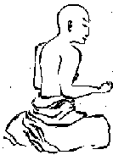 | STEP 3  Position two forearms as the figure shows, clench two hands into a loose fist. With the central point of the shoulder (on the spine) as the fixed point and turn the shoulder, upper arm and forearms clockwise and then counterclockwise as like turning a hoisting tackle or a bicycle peddle. 36 or more times.
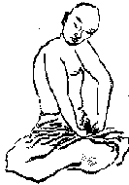 | STEP 4  With arms akimbo (palms resting on the hips, elbows out to the two sides) , slowly turn the head, neck and upper body to the right to watch /gaze right, then turn left to watch /gaze left, keeping spine upright and moving with a slow, gentle rhythm. 24 or more times.
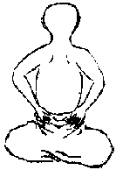 | STEP 5  Put two hands behind and let two palms cover the kidney area, right palm right side, left palm left side. A little while, use all finger tips to rub the kidney area up and down till you feel hot with kidney area. Rest a while and rub again. 36 times or more.
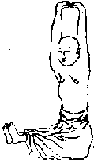
STEP 6
Stretch two legs forward – or keep legs in crossed leg position - cross the fingers of the two hands – placing them on the crown of the head - then turn palms upward, then push two hand upward slowly and use force, slightly imagine pushing heavy things upward. Then slowly lower two hands and let two palms cover the head from above. Repeat the process 18 times or more.
STEP 7
Let the hands rest in the lap, sitting quietly, then let two lines of teeth strike against each other 36 times, feel how the vibration spread around and through the entire body - relaxing all parts of the body.

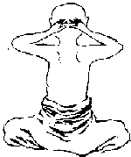

STEP 8
Relax every parts of the body. Place palm of hands over the ears – and press slightly into the ears – then straighten all fingers and let them knock the back side of the head vigorously 48 times or more. Then resume the former position with hands clasped together resting in the lap.

Preparation
After finishing Step 8, enter the silent state and sit cross legged, slightly close two eyes, hands one on top of the other, thumbs touching – much like the statue one views of Buddha - slowly purge of all stray ideas within the heart, position spine upright, and settle mind-will in lower Dantien area. Relax all parts of the body, let tongue rise up to touch the hard palate, with teeth lightly touching – preparing for the silent sitting exercise. Let virtue begin to grow within, releasing all negative qualities and relaxing the body.
This is the Motionless Posture (posture 1) –
Signaling the beginning of the Qigong practice.

The first posture for the Silent Sitting Practice, you should perform ten to fifteen minutes – or more. In the first posture, you hold your hand together before the lower abdomen in your lap (two palms facing upward, right on top, left on bottom, thumbs touching), much like the many statues of Buddha.
The tongue touches the upper palate, back straight, and crown stretching up to heaven.
Mind intention focuses on the lower elixir field.
Sit in the half lotus posture, or legs crossed,
or in a chair with back straight and feet on the ground.
Please put cushions and a quilt under the hip to be comfortable when sitting on the floor.
This is the Motionless Posture (posture 1).

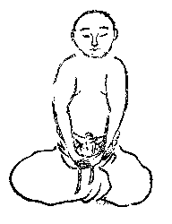

Then slowly raise your two arms to the place before your chest palms facing up in a level manner, fingers facing each other (posture 2).
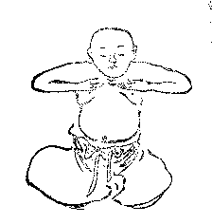

The time for each posture you may change. You have the freedom to decide how much time each posture should use.

Relax every part of the body.
Breathe naturally; do not be concerned about the breath.
Let the natural virtue rise forth internally and blossom like a beautiful lotus flower.
Let the heart be pure.
Rest in Tranquility, Clarity and Stillness.

* The first two postures belong to the preparation postures.

Then slowly push forward your two arms in a level manner, palms facing forward, fingers up.
This posture is called ‘Push Open the door’ (posture 3).
And keep this posture for the time till you could not bear - your arms will quiver later and become sore.
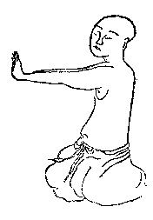
Then slowly draw back your two arms, which is the second posture, repeated again. (posture 2)

Keep this posture for about ten minutes.

Then stretch out two arms to the two sides of the body, palms facing up, fingers stretched out. (posture 5)

Yet you can use this posture in combination with posture 3 and posture 4---- both motion postures. And it is your choice to choose any one of them---posture 3, posture 4, and posture 5). Then keep this posture for the time till you could not bear – 10 minutes. - your arms will quiver -

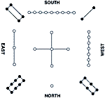

Stretching the arms up to the heavens with the palms facing the sky and the fingers pointing toward each other consists of posture 4.
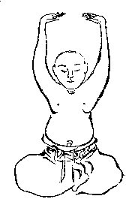

Then draw back your two arms, (the second posture) and keep this posture five to ten minutes.

Then chose any one of posture 3, 4, 5 and stretch out two arms again and keep this posture till you could not bear.
Let the form be natural and you may choose the combination that feels natural.
You may change the order as you feel.
Do not be concerned about a proper order of sequence.

Keep the heart calm and tranquil.

Keep the mind and internal vision directed to the lower elixir filed – the lower tan tien.

Then draw back two arms again to return to posture 2, resting for 5 min time.

Then slowly lower the hands to come back to posture 1, the motionless posture. (Rest ten, fifteen or more minutes in stillness, with no idea of doing anything at all.)
Then when you naturally feel the practice is over, have a slight idea that the darkness in which the universe disappeared in begins to slowly shrink towards your lower elixir field – the lower dantien space.

All things come back into your lower elixir field.

All the Qi and Energy that has circulated in the practice is slowly drawn back to the lower elixir field with a very slight intention – in a very natural way.

Then let all things be natural, rest in silence, and do not think about anything at all.

Relax every part of the body.
Breathe naturally; do not be concerned about the breath.
Let the natural virtue rise forth internally and blossom like a beautiful lotus flower.
Let the heart be pure.
Rest in Tranquility, Clarity and Stillness.

About fifteen minutes later, your practice is over.

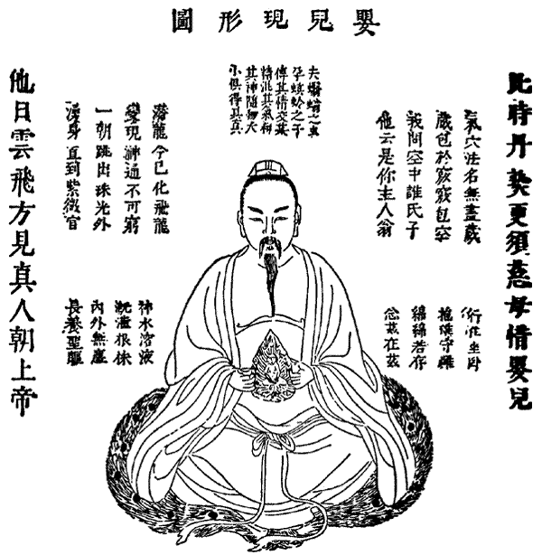

In the beginning you will feel sore with your arms - it is natural. You may feel so bad that you think you will stop the practice. Your diseases or symptoms will get worse, perhaps.

But please have faith and continue the practice with a pure heart.

But about 15 or 20 days later you begin to feel very good, very light, and the limbs and body will vibrate and be full of Qi or Vital Energy.

Persistence in the practice is an essential thing for successful qigong practice.

With no experience, people will always regard qigong as a lie, or a dream.

Only through daily practice people can know or understand qigong theory, through personal experience.

Yet, the practice should be a continuous one.
You are advised to practice two (or three) times every day. Once in the morning, once in the evening, once at midnight, or as your schedule will permit.

Even just one session a day can bring great benefit.

Here is a sample time schedule for you to view for daily practice schedule.

Early morning practice | 5:15 am -- 6: 45 am
Noon practice | 11:00 am - 12:30 pm
Evening practice | 7:30 pm - 9:00 pm

We follow such a schedule when we practice intensive Taoist meditation retreats in China. Yet in daily life with work, please make time as you can in a balanced manner.

After midnight you can practice another time if you can wake up. That is perhaps a best time for practice, as it is a very quiet time and the Vital Energy of Nature is very balanced and pure at this time.
It needs strong will power to gain progress with qigong practice.

No persistence in the practice every day no real progress.
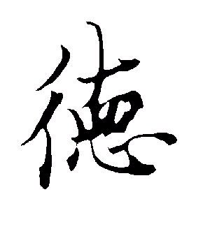
Before practice please air your room first.

The air in your room should be clear.

Your room should be away from noise.

Lead a quiet and simple life if possible.

During the period of practice do the best to not have too much sex, or to be without any sexual relations if possible, or read and watch the material and movies concerning sex.

The energy that is consumed during sexual excitement is very important and we must preserve, use and transform this energy in the first stages of laying the foundation in Qigong.

Be moderate and natural in your life.

Take vegetable, seldom eat food
of a sweet, cold, fatty, or raw nature.
Try to drink boiled hot water when thirsty, this is very important for the health of the lower elixir field.
Never take cold iced drinks, no smoking, and no alcohol.
This is a very important thing.

In the meantime, don't take too much Western medicine. When people begin to feel good, they can gradually decrease the western medicine they take.

We will not guarantee practitioners can accomplish something.

All success depends upon you and your own effort.

There are many things needing help I think.

Please feel free to contact us if you have any question on this basic practice.

Please practice at least two hours every day if possible or as your schedule permits.
The breath should proceed in a natural way.

Never force the breath

Then it will become more feeble and feeble and very soft.

Later you will feel nothing about breath.

At a later stage of qigong practice the breath will stop naturally, the blood will flow no longer; your heart will beat no more.

All seems to have been dead, for no man knows how many years.

Nothing comes in, nothing goes out.

All comes upon a constant stillness.

Of course, to reach that stage will need long time of practice.

Nothing forced. All should be in a natural way.

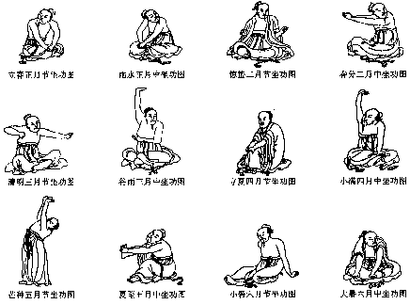

The first means the first posture; the second means the second posture and so on.
Yes, there is a posture we repeat three times.

Among all the postures, posture 3, 4, 5 are motion postures. Posture 1 is motionless posture. Posture 2 is a medium posture, which means they possess both the nature of motion and stillness.
Only undergoing all of the gradual processes from motion to stillness and from stillness to motion, the vital energy vapor (Qi) can be a healthy one and possess no bias with regard to motion or stillness, or is unprejudiced – such a quality of Qi can be used by patients to cure diseases.

The vital-vapor or Qi that is biased towards one side (motion or stillness) will do harm to human's health.
I can give you some example of sets of practice for the postures for you to follow:
1,2,3,2,4,2,1.
1,2,4,2,3,2,1.
1,2,5,2,4,2,1.
1,2,3,2,5,2,1.
1,2,3,2,4,2,1.
1,2,4,2,5,2,1.
and so on.

You can choose any one of them. Let it be natural.
Continue the practice once in the morning and once in the evening if possible and never stop. When in practice relax every parts of the body and let yourself feel comfortable; let your heart shine with great beauty, love and virtue. Be pure, natural and full of virtue. Put some things under the hip to let the hip be a little higher then the legs. That will let you feel comfortable. Be comfortable when you sit.

Sitting on a quilt is ideal. Let the spine be upright. Let the tongue press against the roof of the mouth. Teeth lightly closed, breathing very gently in and out through the nose.

Let the heart be pure, shining its light naturally.

At beginning it is very difficult to practice qigong because it is boredom, and sore with the arms and you have no good feeling of qi. But if you can continue you will feel better and better. So sometime a qigong teacher is a must for new practitioners who can help them to pass over the difficult four to five days by means of sending qi into their bodies and advising them to take special herbal medicine that are good for opening up channels and collateral.
The practitioners should pay much attention upon the food they take. The food should not contain too much peppery or spicy element. Most of the food should be vegetable, like Chinese cabbage, soy bean curd, soy sprouts, turnip, and such like which have no strong flavor. Eating very less fat, no dried food, and no food of sweet, cold, raw, very salty nature. Be smart, natural and moderate in the food you eat.
Just lead a simple life. Be pure in your heart. Be virtuous.
Never touch any sex-related materials if possible.
Such as books, magazines, TV programs, etc.

In the first three months of practice this is very important.
Have a moderate and natural sexual life, if possible – having a time of no sex is best for the first 90 days. Do not have excess sexual relations if possible – this is important as the sexual energy is a foundation for the success of building Qi.
Qigong can open up almost all the most tiny channels and collateral which connect the main energetic channels and collateral within the body.
At first it can greatly strengthening man's immune system. Then using the internal medicine you have gained from cultivation of the Qi, patients can kill all virus and things not suitable for human's body.

Then the student will possess a new life in every aspect.
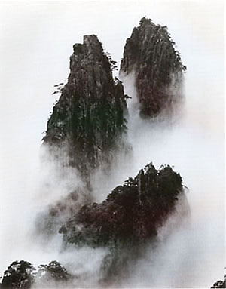

You must have unswerving resolution and will power to continue with the practice; otherwise you are advised not to practice because your former efforts will be gone with the wind, in an instant.
Always keep your mind peaceful.

Man's lifetime is a transient time, much like a soap bubble.
We are much like fish who never know they will die without water.

We always think we are powerful.

We pay much attention upon our existence and exhausting our sense organs to indulge in all man-made activities

Therefore we should realize this truth and reverse the course we are traveling in.

Moving in the opposite direction of the common man.

Working daily to cultivate our heart and attain stillness.
Cultivating our Qi for health, harmony and happiness.
Seeking to gain union with the Tao.

Copyright 2003 Teacher Hu Xuezhi and Jesse Lee Parker. All rights reserved. No portion of this work may be copied, altered, changed, reproduced, distributed or published in any way without written permission from author.

